
CAPSTONE PROJECT – I
SPEC Traffic AI: An Explainable Computer Vision Platform for Indian Traffic Violation Detection with Human-in-the-Loop E-Challan Verification and Advisory Signal Timing
Submitted by
Rishik Reddy P (23WU0102149)
Rohan Reddy (23WU0102169)
Hari Ramaneti (23WU0102135)

Under the guidance of
Prof. Meher Gayatri
Department of Computer Science and Engineering
Woxsen University, School of Technology
Academic Year 2026–2027 | 7th Semester
TABLE OF CONTENTS
Abstract iii
1. Introduction 1
1.1 Background 1
1.2 Problem Statement 1
1.3 Scope 1
2. Technology Review 2
2.1 Detection on Indian Roads 2
2.2 End-to-End Enforcement Systems 2
2.3 Effectiveness of Automated Enforcement 3
2.4 Signal Control and Calibration 3
3. Review Summary, Research Gap and Objectives 3
3.1 Review Summary and Limitations of Prior Work 3
3.2 Research Gap 4
3.3 Objectives 4
4. Methodology 4
4.1 System Architecture 4
4.2 Temporal Consistency and Abstention 5
4.3 Calibration by Measurement 5
4.4 Evidence Packaging 6
4.5 Evidence Defensibility Score 6
4.6 Explainability by Construction 7
5. Implementation and Results 7
5.1 Detector Training and Evaluation 7
5.2 The Viewpoint Domain Gap 8
5.3 Calibration and False-Positive Reduction 9
5.4 Rule Verification Without Footage 10
5.5 Detection of Riders and Plates 10
5.6 Officer Review Portal and Signal Timing 10
5.7 Score Distribution Across the Evidence Set 12
5.8 Computational Performance 12
6. Conclusion and Future Scope 13
6.1 Conclusion 13
6.2 Future Scope 13
References 14

Capstone Project-I · School of Technology · Woxsen University
Rishik Reddy P (23WU0102149) · Rohan Reddy (23WU0102169) · Hari Ramaneti (23WU0102135) Mentor: Prof. Meher Gayatri

Abstract
India records the highest number of road-accident fatalities worldwide, yet manual enforcement cannot scale to urban vehicle density and existing closed-circuit television infrastructure remains confined to passive monitoring. Detectors trained on Western datasets contain no auto-rickshaw class, rendering them structurally incapable of enforcing violations against a substantial share of Indian traffic. This project develops SPEC Traffic AI, a modular enforcement platform for Indian road conditions. A single shared perception pass performs vehicle and number-plate detection, ByteTrack assigns persistent identities, and an extensible rule engine evaluates violations as geometric modules configured per camera. Confirmed violations produce an evidence package spanning approach, violation and departure with a plain-language reason trace. A novel Evidence Defensibility Score assesses whether a detection would withstand legal challenge and routes it for officer verification accordingly. The same perception pass measures congestion per junction arm in Passenger Car Units, which Webster's method converts into an advisory green-time split the system deliberately cannot actuate. Evaluation established 0.703 mAP@50 on a held-out test split and quantified a viewpoint domain gap between dashcam imagery and enforcement-camera geometry. The platform allows authorities to scale enforcement while ensuring no challan issues without human approval under the Motor Vehicles Act.
Keywords: Traffic Violation Detection; Computer Vision; Intelligent Transportation Systems; Human-in-the-Loop Verification; Explainable AI; Adaptive Signal Control

1. Introduction

1.1 Background
Road safety represents one of India's most persistent public-health failures. The Ministry of Road Transport and Highways reports that over-speeding contributed to 68.4 per cent of road accidents during 2023, and that 54,568 persons were killed while not wearing protective headgear [8]. Enforcement capacity has not kept pace with vehicle growth: manual policing cannot observe every junction continuously, and the extensive closed-circuit television networks installed under smart-city programmes remain largely passive, recording incidents rather than acting upon them.
The economic case for automation is established, yet operational experience shows that detection volume alone is insufficient. The Safe Kerala deployment recorded 66.41 lakh violations in its first year and issued 64.72 lakh challans valued at approximately 428 crore rupees, of which 76.7 crore rupees was collected. The shortfall is administrative rather than technical, but it demonstrates that a violation detected is not a penalty enforced, and that the stages following detection determine whether an enforcement system produces any deterrent effect.

1.2 Problem Statement
Two deficiencies prevent existing computer-vision systems from closing this gap. First, detectors trained on general-purpose datasets such as COCO contain no auto-rickshaw class and are therefore structurally unable to enforce against a substantial proportion of Indian traffic. Second, and less widely acknowledged, published violation-detection systems optimise for whether an offence was detected rather than whether the resulting evidence could survive legal challenge. Under Section 65B of the Indian Evidence Act, since superseded by Section 63 of the Bharatiya Sakshya Adhiniyam 2023, electronic records are inadmissible without certification [13]. Evidence quality is consequently a statutory precondition rather than a refinement.

1.3 Scope
This project delivers a working detection and evidence-generation pipeline for Indian road conditions, an officer review portal implementing human-in-the-loop challan approval, and an advisory adaptive signal-timing module. Automatic number-plate recognition, multi-camera deployment and integration with departmental challan systems lie outside the present scope and are addressed as future work.

2. Technology Review

2.1 Detection on Indian Roads
Indian-road object detection is substantially solved as a research problem. DriveIndia provides a large annotated dataset of diverse Indian traffic scenes and reports a baseline of 78.7 per cent mAP@50 [1]. More recently, the Urban Vision Hackathon dataset (UVH-26) released 26,646 high-resolution frames sampled from approximately 2,800 operational Safe-City closed-circuit cameras in Bengaluru, annotated across fourteen India-specific vehicle classes, together with six fine-tuned detection models [4]. Both employ the YOLOv11 architecture [11], whose principal enhancements concern feature aggregation and inference efficiency. Persistent vehicle identity is supplied by ByteTrack, which associates every detection box rather than discarding low-confidence candidates, and which is constructed from a Kalman filter and Hungarian assignment rather than a learned model [10].

2.2 End-to-End Enforcement Systems
Complete pipelines already exist. Ravish et al. describe a system performing helmet detection, triple-riding identification, number-plate recognition and automated ticket generation [2]. Ren reports a violation-detection system combining computer vision with human-computer interaction, achieving accuracies exceeding 96.9 per cent across eight violation categories and 99.7 per cent for red-light running [3]. These figures are obtained under laboratory conditions; the study reports neither a held-out evaluation split nor deployment against operational camera feeds, so the extent to which they transfer to field conditions remains undetermined.
Both systems treat number-plate recognition as a solved subsystem. Field measurement contradicts this. Rhead et al. examined automatic number-plate recognition against real-world plate conditions and documented substantial misread rates arising from non-standard fonts, physical damage, mounting angle and illumination [9]. Because a challan is issued to a registered vehicle rather than to a bounding box, plate recognition accuracy bounds the usable output of any enforcement pipeline irrespective of detection performance.

2.3 Effectiveness of Automated Enforcement
Evidence that automated enforcement reduces harm is strong. A Cochrane systematic review of thirty-five studies found crash reductions between 8 and 49 per cent in the vicinity of camera sites [5]. A subsequent meta-analysis attributed a 51 per cent reduction in fatal crashes to spot cameras and a 56 per cent reduction in killed-or-seriously-injured crashes to section control [6].

2.4 Signal Control and Calibration
Adaptive signal timing rests on Webster's method, which derives an optimum cycle length from the ratio of demand flow to saturation flow and remains the basis of signal design practice, including Indian Roads Congress guidance [7], [12]. Camera calibration for surveillance applications has been approached through three-dimensional model alignment [15] and through automatic methods for wide-angle lenses [16], both of which bear directly on scaling any geometric rule beyond a single installation.
A consideration specific to Indian conditions concerns how demand is measured. Western adaptive systems typically count vehicles, an approximation acceptable where the traffic stream is comparatively homogeneous. Indian traffic is not: an approach carrying forty motorcycles and one carrying forty buses impose substantially different demands on junction capacity. Indian Roads Congress guidance addresses this through Passenger Car Unit equivalency factors, which weight each vehicle class by its effective consumption of road capacity [12]. Demand measurement intended for Indian junctions must therefore be expressed in Passenger Car Units rather than in raw vehicle counts.

3. Review Summary, Research Gap and Objectives

3.1 Review Summary and Limitations of Prior Work
Three limitations recur across the reviewed literature. First, reported accuracies are frequently obtained without a held-out evaluation split; Ren reports laboratory accuracy with neither a held-out split nor field deployment [3], and Ravish et al. present a working prototype without quantified generalisation [2]. Second, viewpoint transfer is rarely tested. BMD-45 measured a detector achieving 83.8 per cent mAP in-domain falling to 33.6 per cent across domains on Indian closed-circuit footage [14], a collapse absent from the violation-detection literature. Third, and most consequentially, no reviewed system models whether its own evidence would be admissible. Operational experience supports this concern: Bengaluru's Intelligent Traffic Management System reports helmet detection at 75–80 per cent accuracy, reaching 99.9 per cent only through manual revalidation of every fine prior to issue [17].

3.2 Research Gap
The gap addressed is therefore not detection accuracy but evidential defensibility. Detection confidence expresses certainty that an object belongs to a class; it expresses nothing about whether a resulting challan would survive contest. No published system carries an evidence-quality metric or a chain-of-custody concept within the vision pipeline itself.

3.3 Objectives
1. To train and evaluate a detector on Indian road data recognising vehicle classes
absent from general-purpose models, reporting performance on a held-out split.
2. To construct a modular rule engine in which each violation is an independent,
calibrated geometric module operating over one shared perception pass.
3. To design and implement a quantitative measure of evidential defensibility that
triages detections for officer review before any challan is issued.
4. To demonstrate that the same perception pass can additionally support advisory
junction-signal timing without additional inference cost.

4. Methodology

4.1 System Architecture
The architecture separates perception from judgement. A single detection pass produces frame results consumed independently by the rule engine and by the signal-demand module, as shown in Figure 1. Because detection is the computationally expensive stage and executes once, adding the signal-timing consumer incurred no measurable per-frame cost.
Rules are self-registering modules declaring the classes they inspect and the calibration they require. Adding a violation is a single file; deploying to a new camera is a single configuration file.
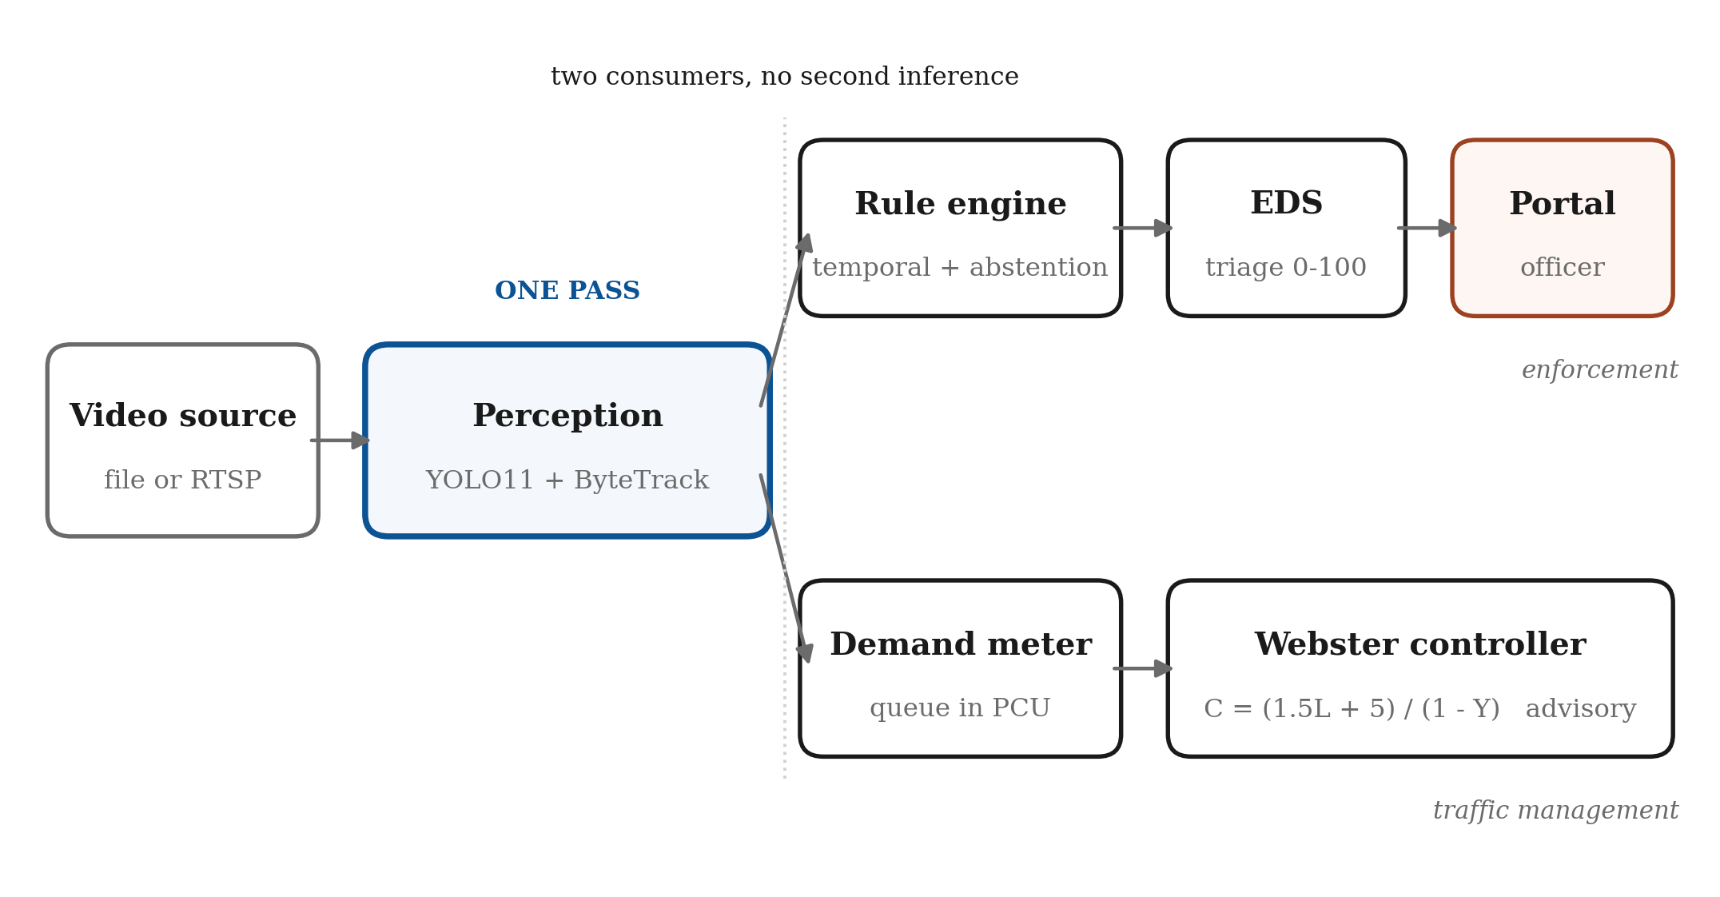
Figure 1: System architecture. One perception pass serves two independent consumers, so adding signal timing introduced no additional inference cost.

4.2 Temporal Consistency and Abstention
Two design decisions dominate false-positive behaviour. Temporal consistency is implemented in the rule base class rather than in individual rules, requiring a condition to hold for a defined number of consecutive frames on the same track before a violation is emitted. Placing it in the base class means every rule inherits it rather than reimplementing it inconsistently.
Abstention is treated as a first-class outcome. Where a vehicle's road-contact point falls outside every declared lane, the wrong-way rule returns no verdict rather than assuming a default direction. Where no homography exists, no speed is reported. Where insufficient traffic has been observed, the signal controller recommends the existing fixed plan. For a system terminating in a monetary penalty, silence is inexpensive whereas a wrongful challan is not.

4.3 Calibration by Measurement
Geometric rules depend on per-camera calibration: lane polygons, permitted headings, stop lines and a pixel-to-metre homography. Permitted heading proved the critical parameter. Entered in reverse, the wrong-way rule inverts, flagging every lawful vehicle while ignoring actual offenders, and the rule cannot detect this condition internally.
A still frame does not convey motion, so heading was derived from the footage instead. Vehicle tracks are accumulated, each track's net direction computed, and the dominant heading per lane reported together with a coherence measure. Where traffic within a polygon does not share a direction, the tool reports incoherence rather than selecting a majority, indicating that the polygon spans opposing carriageways and must be redrawn.

4.4 Evidence Packaging
A violation occupies an instant, whereas evidence must establish context. The system maintains a rolling frame buffer and, upon confirmation, writes a package spanning the approach, the violation and the departure. The package contains the video clip, the frame at the moment of violation with the offending vehicle delineated, an earlier approach frame, the cropped number plate where one was located, and a machine-readable record carrying the statutory section, the quantitative detail underlying the verdict, and a plain-language reason trace stating in ordinary words why the vehicle was flagged.
The reason trace is a deliberate design decision. An officer presented only with a confidence value cannot assess whether a detection is sound, whereas a statement that a vehicle travelled a measured number of degrees against the permitted direction of its lane, sustained over a measured distance, can be disputed on its own terms. Penalties are drawn from a configurable schedule carrying the statutory section and a verification flag displayed alongside every amount. Offences whose evidence is inadmissible by construction, such as vision-derived speed, are prevented from being approved as challans irrespective of operator action.

4.5 Evidence Defensibility Score
Each violation is scored across five weighted dimensions: plate readability (0.30), subject visibility (0.20), track integrity (0.20), rule margin (0.15) and contextual certainty (0.15). Scores at or above 80 are pre-filled for approval, 50 to 79 are routed for review, and those below 50 are dropped. Where a dimension cannot be measured, its weight is redistributed proportionally across the remainder and the contributing dimensions are recorded, so that the score spans its full range and the omission remains visible.
Plate readability is measured from the image rather than taken from detector confidence, since the two answer different questions. Readability combines plate width in source pixels, sharpness by variance of the Laplacian, and contrast, multiplied by detector confidence so that either uncertainty about the object or illegibility of the characters reduces the score.

4.6 Explainability by Construction
Signal state is determined by hue-saturation-value thresholding over a calibrated signal-head region rather than by a learned classifier, and the resulting pixel fraction is recorded in the evidence. The statement that a given proportion of pixels within the signal head matched red is defensible under examination in a way that an unexplained network output is not. The same reasoning governs the choice of Webster's method for signal timing: four lines of arithmetic with physically meaningful terms can be verified by the traffic engineer who must authorise the plan.

5. Implementation and Results

5.1 Detector Training and Evaluation
A YOLOv11-small model was fine-tuned on DriveIndia for 50 epochs on a 6 GB laptop GPU. The class set was reduced from 28 to 21, as seven classes contained between zero and twenty-two instances and could not be learned. Performance on the official held-out test split is reported in Table 1.
Table 1: Detector performance across data splits
Split | mAP@50 | mAP@50–95 | Precision | Recall
Train | 0.850 | 0.752 | 0.832 | 0.763
Validation | 0.716 | 0.598 | 0.721 | 0.679
Test | 0.703 | 0.606 | 0.620 | 0.671

Restricting the mean to the eighteen adequately supported classes yields 0.800, and to the seven enforcement-relevant classes 0.868. Auto-rickshaw, absent from COCO, reached 0.888. The train-to-test generalisation gap of 0.147 is reported rather than omitted; the close agreement between validation and test figures indicates a representative split. The gap is shown across splits in Figure 2, and accuracy for each individual class in Figure 3.
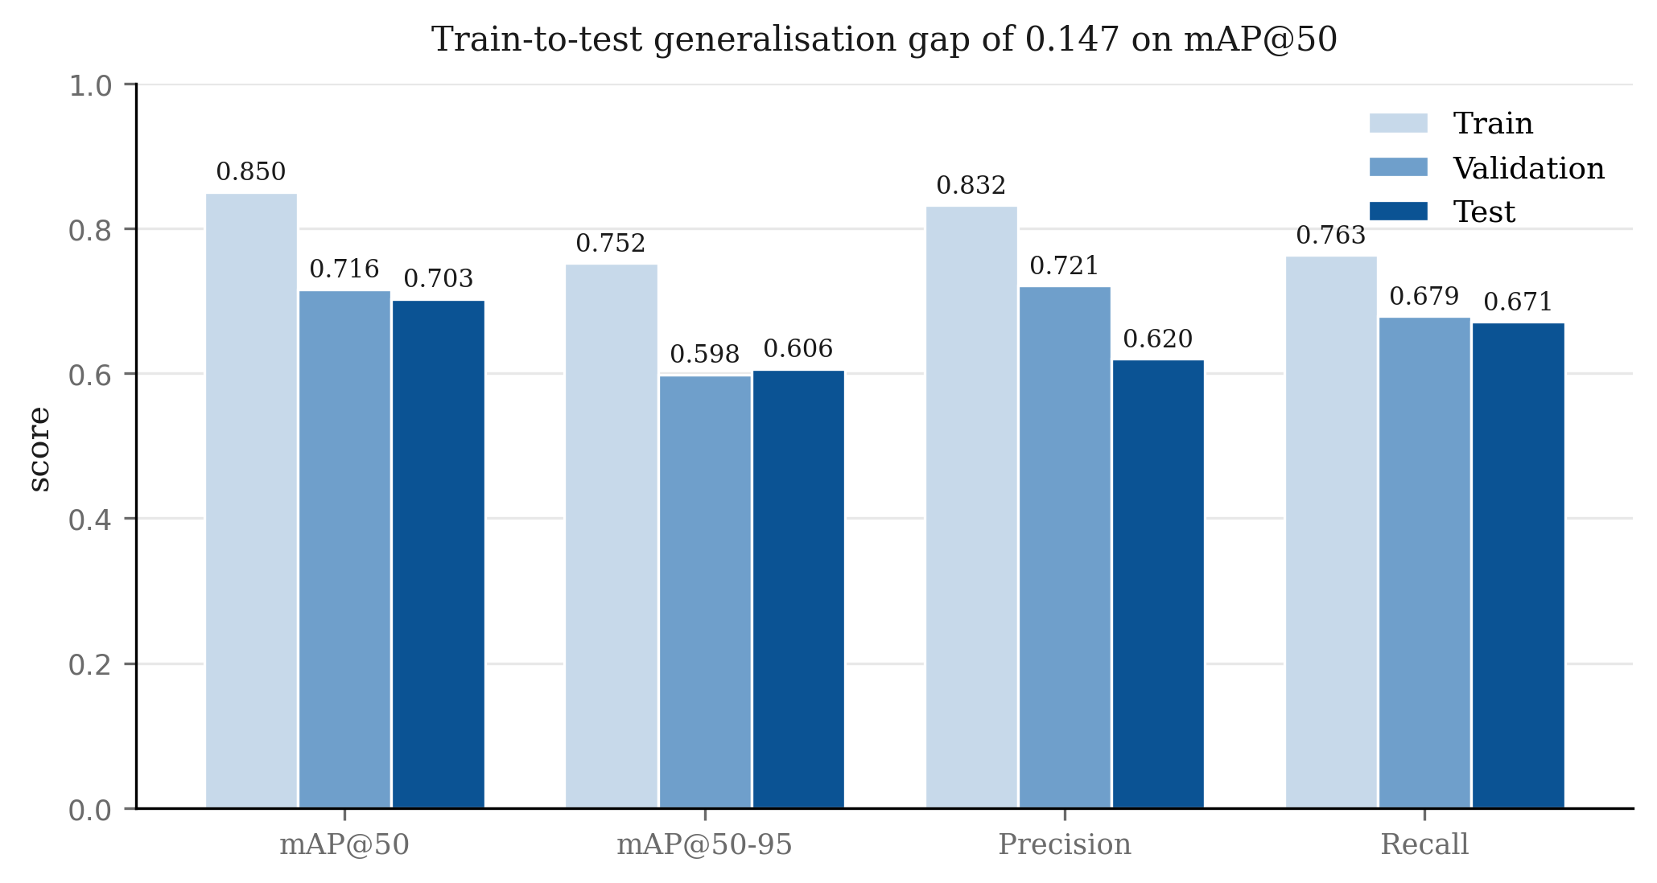
Figure 2: Generalisation gap across the train, validation and test splits.
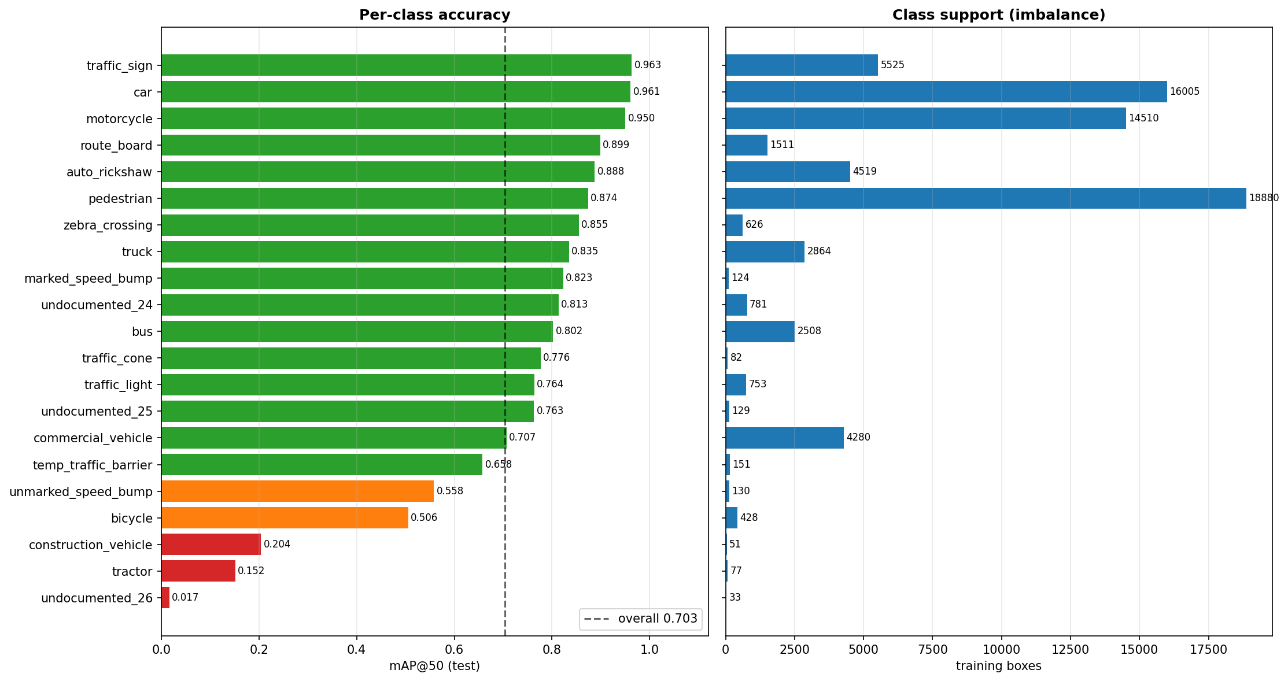
Figure 3: Per-class detection accuracy on the held-out test split.

5.2 The Viewpoint Domain Gap
Testing on elevated footage revealed systematic misclassification of large vehicles. Comparison against a detector trained on enforcement-camera imagery quantified the effect. Both detectors were run on identical frames at the deployed inference settings, an input size of 1280 pixels and a confidence floor of 0.25. On a single frame the DriveIndia fine-tune produced 10 detections against the UVH-26 model's 56, and four of those ten were labelled bus, among them a sport-utility vehicle at 0.75 confidence, in a scene containing one bus (Figure 4). Across six frames sampled evenly through the sequence the totals were 44 and 389, the fine-tune never exceeding 14 detections on a frame in which the comparison model found 65. This independently corroborates the cross-domain collapse reported for BMD-45 [14], and the UVH-26 model was consequently adopted as the default detector for elevated cameras.
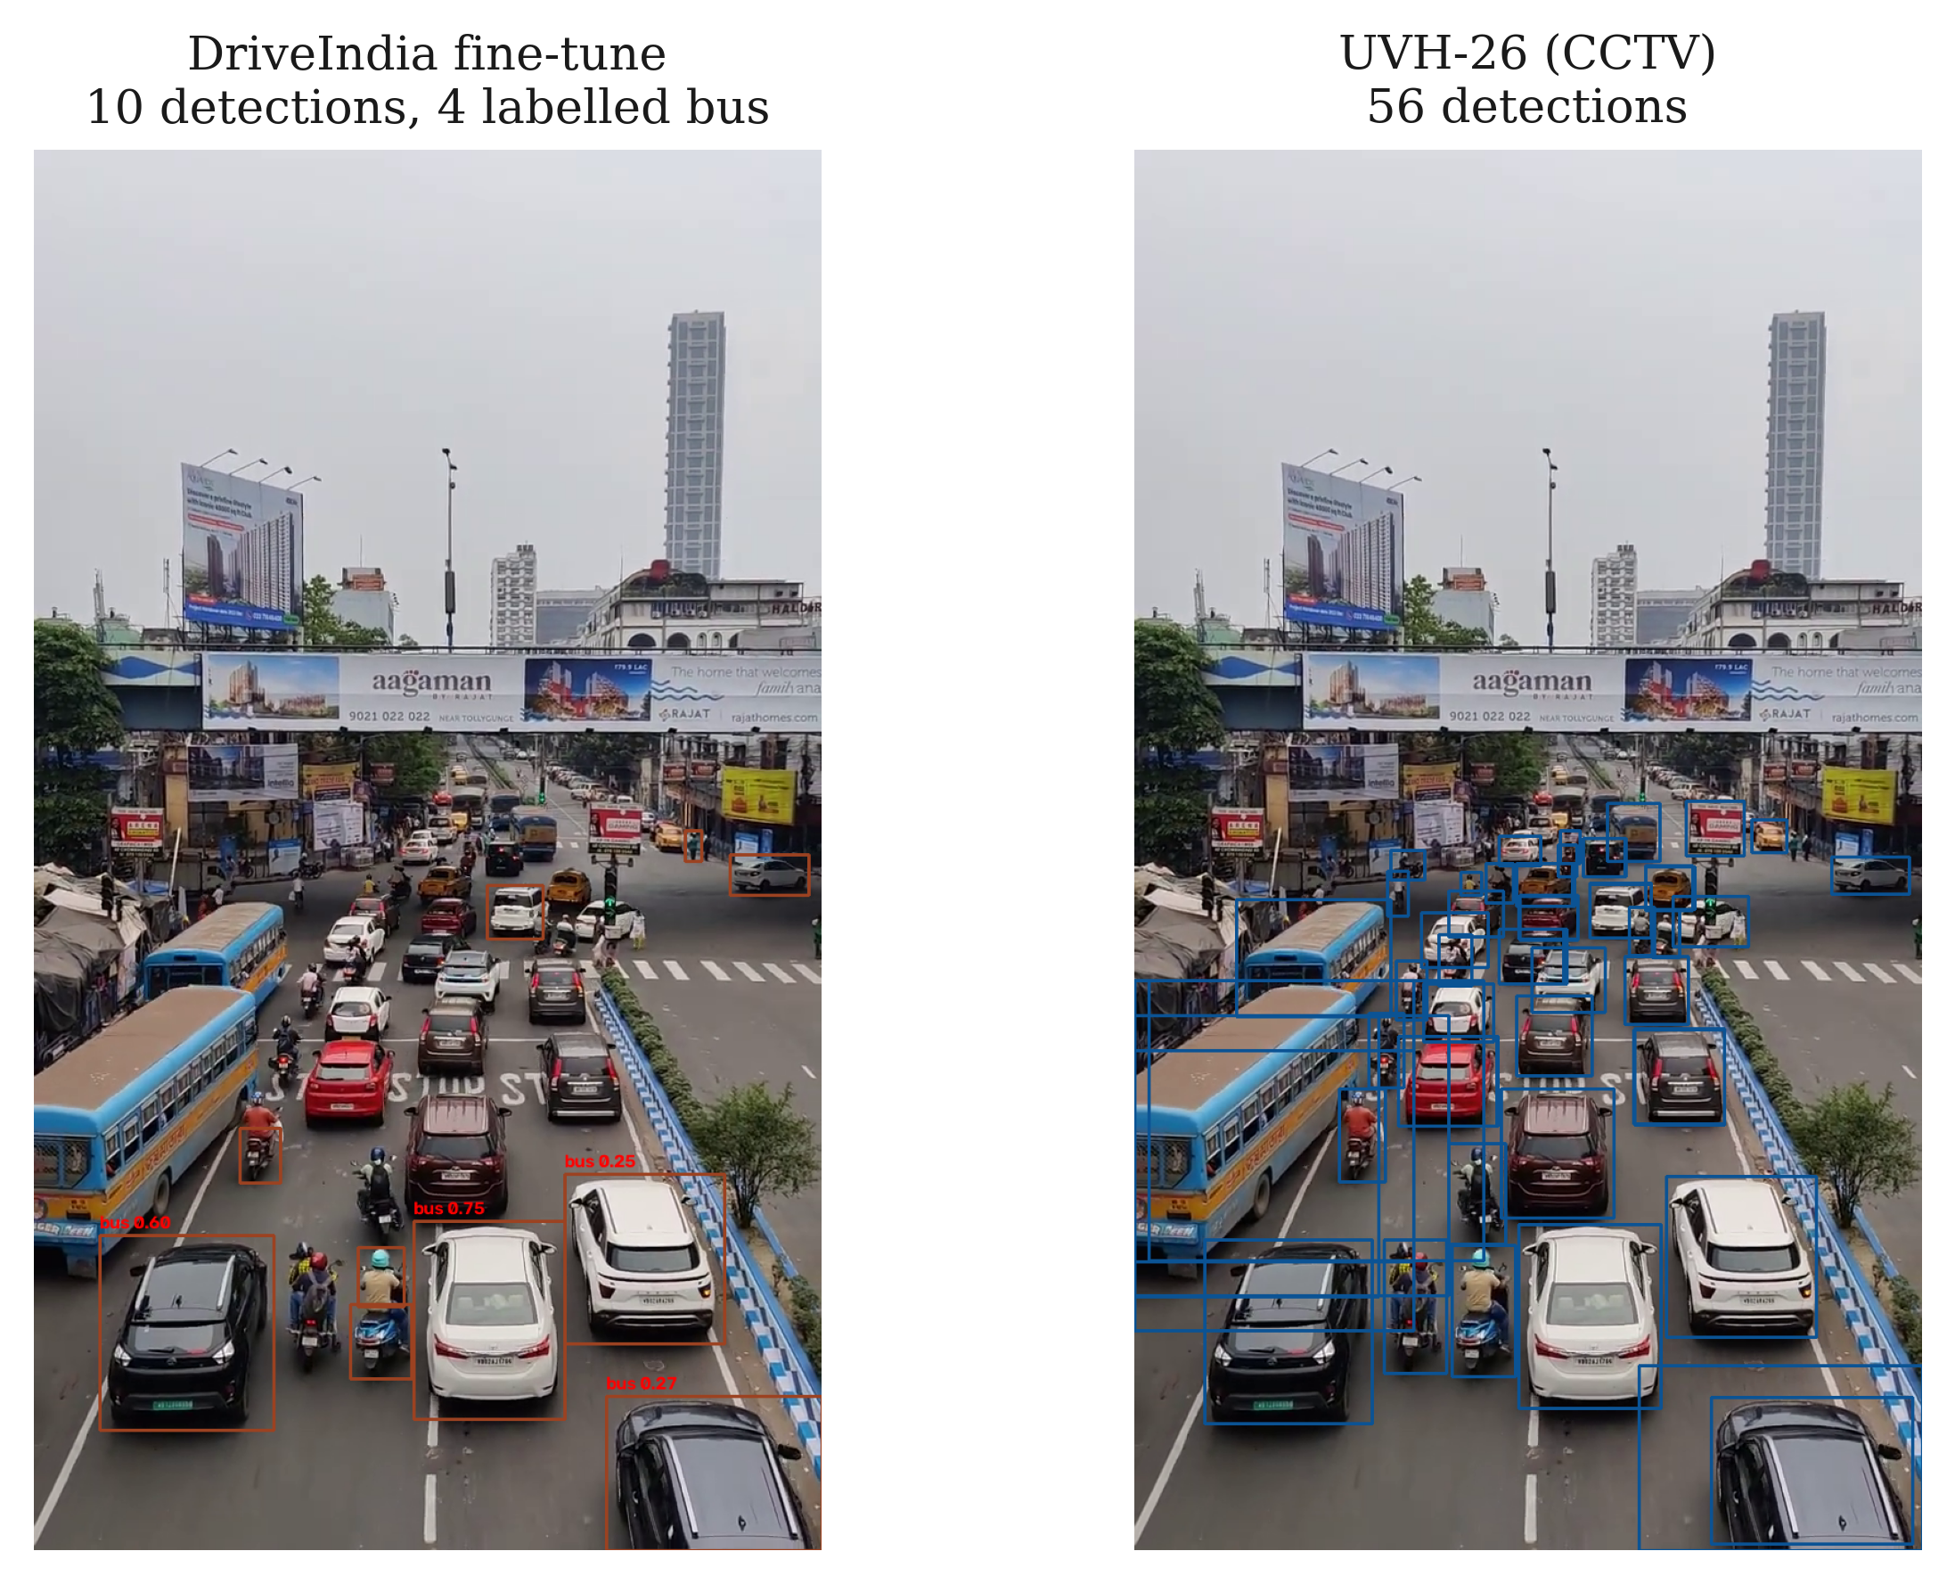
Figure 4: Viewpoint domain gap on one frame at identical inference settings. The DriveIndia fine-tune (left) returns 10 detections and labels four of them bus, including the black sport-utility vehicle; the UVH-26 model (right) returns 56.

5.3 Calibration and False-Positive Reduction
The calibration methodology described in Section 4.3 was validated directly. An initial hand-entered calibration produced fifteen wrong-way violations. Measurement reported one lane coherent at 0.92 with complete agreement, and a second incoherent at 0.42 with 70 per cent of tracks opposing the declared heading; eleven of the fifteen violations originated in the latter. With the heading corrected and default thresholds restored, fifteen violations reduced to one, at 173 degrees against the flow, by a vehicle moving contrary to eleven of twenty-one tracked vehicles.

5.4 Rule Verification Without Footage
Three rules could not be exercised by available footage. Rather than leave them unverified, twenty-two assertions were constructed covering both halves of each rule's contract: that it fires on the offence, and that it abstains on the lawful case most resembling it. All twenty-two pass.

5.5 Detection of Riders and Plates
Two measured limitations are reported. Across 1,467 motorcycle detections spanning two datasets, the detector never placed two persons on the same motorcycle, because the training annotation convention treats a rider as part of the motorcycle boundary rather than as a separate pedestrian. Triple riding and helmet compliance are therefore unreachable without rider-annotated data.
Plate availability proved similarly constrained. Of twenty-one violations, three carried a detected plate, at widths of 17, 23 and 41 pixels, all below the threshold at which characters remain legible. Sampling forty frames from operational Bengaluru enforcement cameras produced a median plate width of 36 pixels, with only 30 per cent at or above 45 pixels. This indicates that the camera observing an offence and the camera identifying the vehicle are necessarily different instruments.

5.6 Officer Review Portal and Signal Timing
The portal presents captured vehicles as a filterable gallery, each violation as a draft challan with statutory section and penalty, and annotated playback of processed runs. Three decisions are available: approval, rejection, and escalation to a second reviewer who records a citation in their own words. Decisions are written to the evidence package, so that a folder remains self-describing wherever it is copied, and to an append-only log retaining the complete history including reversals. The log records the defensibility score at the moment of decision and the time the reviewer spent on screen, both of which are required for subsequent validation of the score against human judgement.
Escalation is not a weaker form of rejection. It routes the package to a second reviewer who examines the footage and records a citation in their own words, and citations accumulate rather than overwrite, so that a package escalated and subsequently approved carries two human attestations. Given that certification of electronic records depends upon human attestation, retaining both is a requirement of the chain of custody rather than an interface convenience. A draft challan as presented to the reviewing officer is shown in Figure 5.
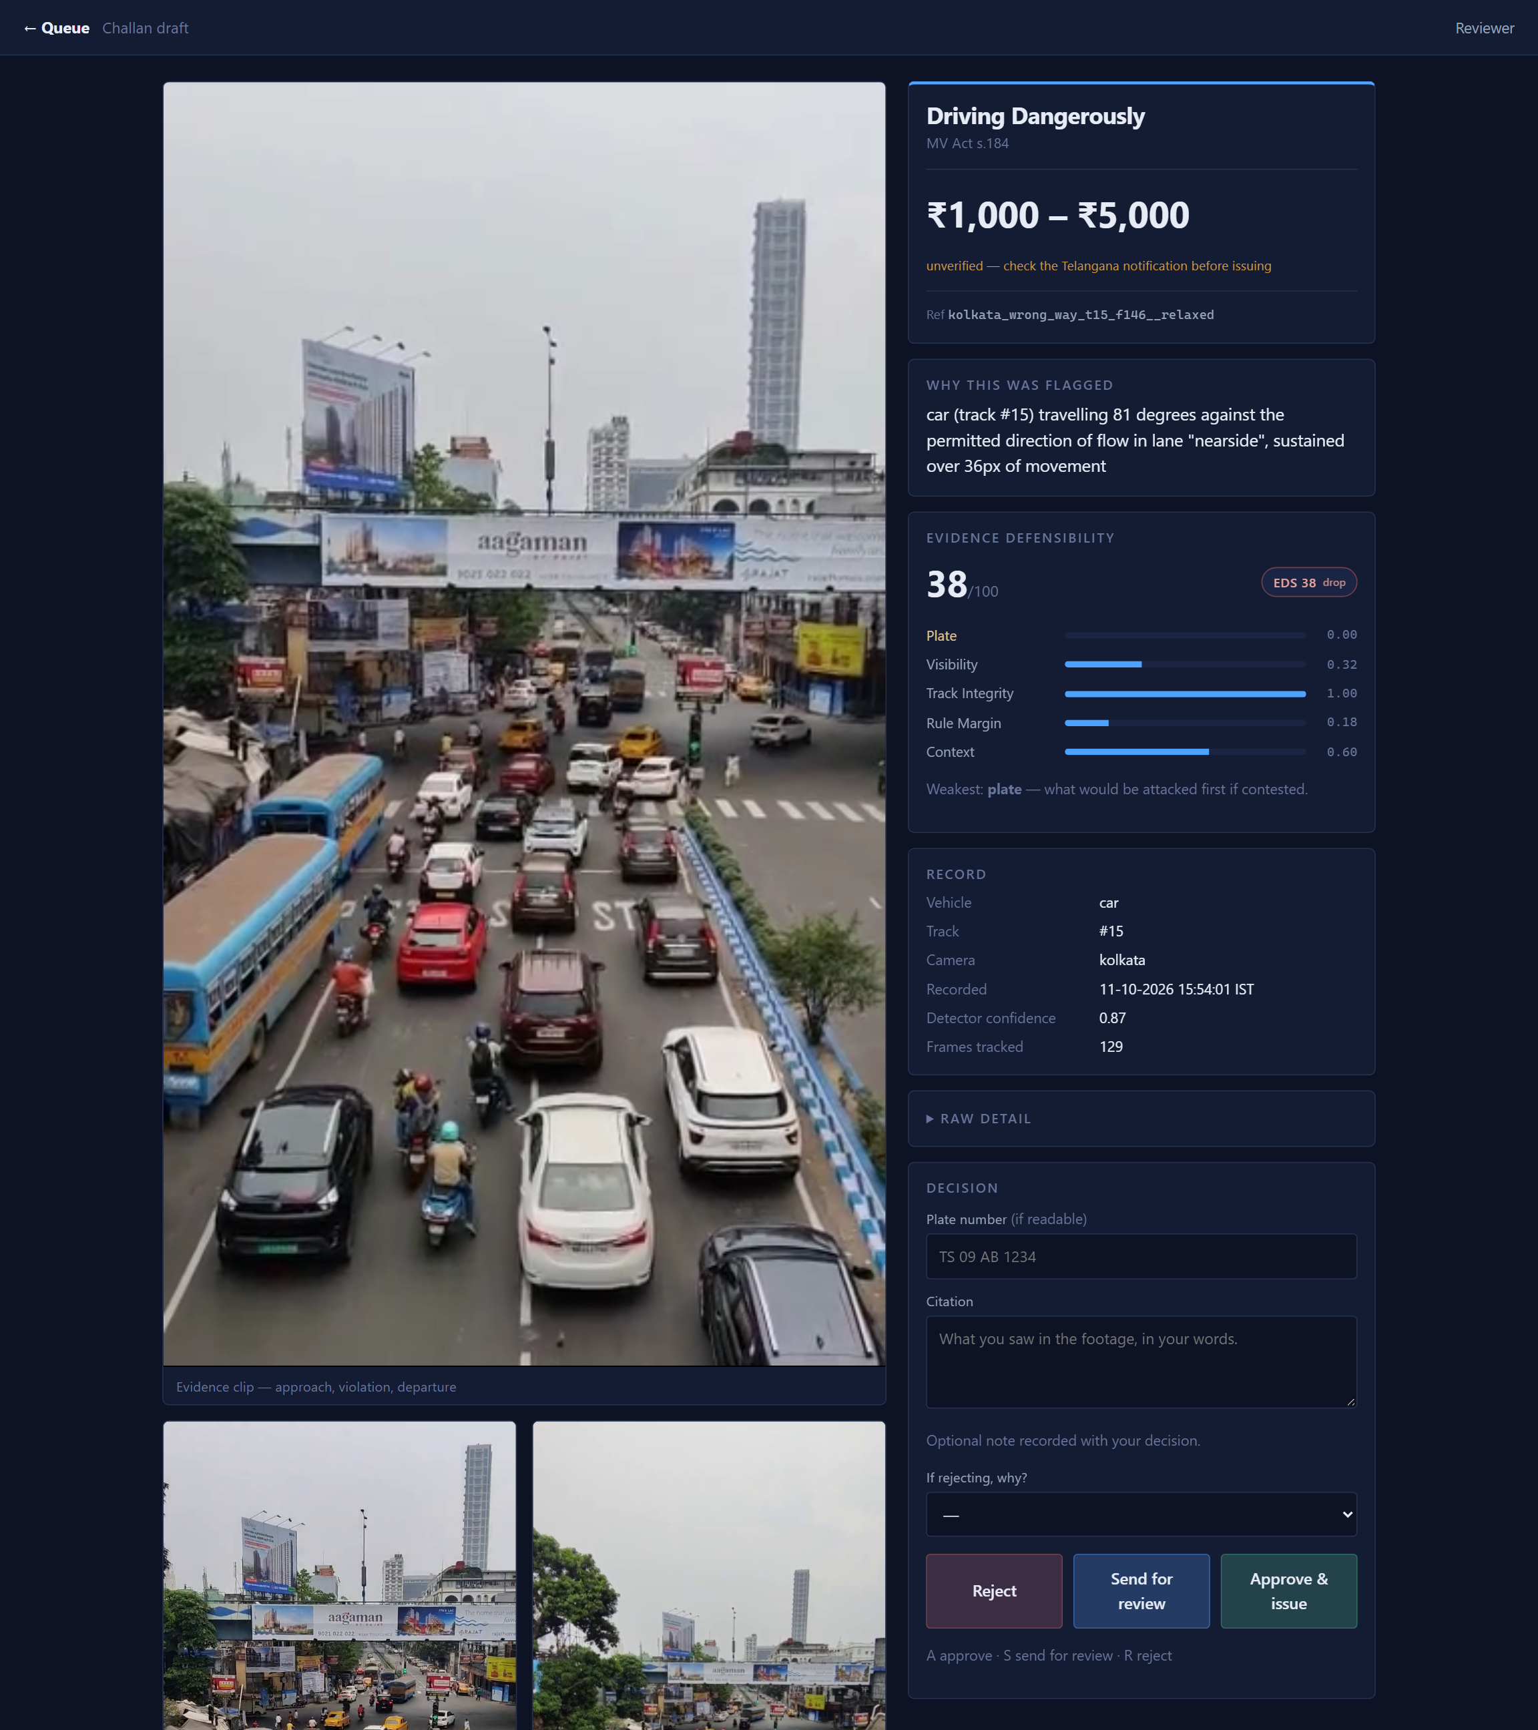
Figure 5: Officer review portal, showing a draft challan with the violation, the defensibility score and the statutory penalty.
The signal controller was verified across four scripted demand scenarios. Green time follows measured queue, increasing from 37 to 57 seconds as demand built; an empty arm continued to receive its minimum allocation each cycle; and beyond practical capacity the controller reported the condition rather than returning an unusable cycle length. The resulting allocation is shown in Figure 6.
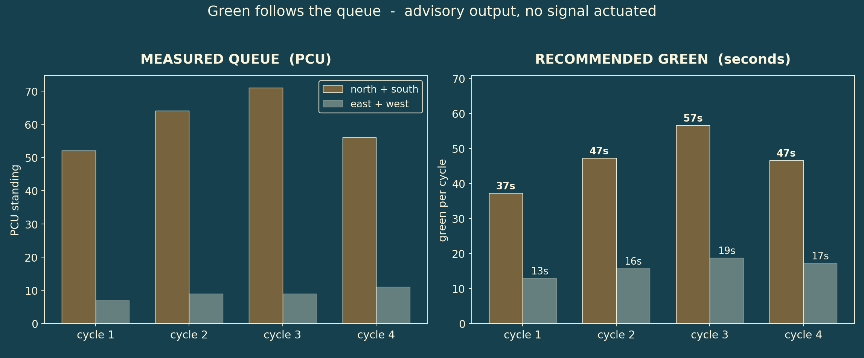
Figure 6: Green time allocation following measured queue across the scripted demand scenarios.

5.7 Score Distribution Across the Evidence Set
Twenty-one evidence packages were generated from a single camera by varying rule sensitivity across four passes while holding calibration fixed, producing a range of evidence quality rather than a uniformly strong set. Defensibility scores distributed across all three bands: five qualified for automatic preparation, twelve for officer review and four for rejection.
The distinction between varying sensitivity and varying calibration is material. Sensitivity expresses how readily a rule reacts, and relaxing it yields genuinely marginal evidence suitable for evaluating a triage mechanism. Calibration expresses a claim about the physical scene, and relaxing it would yield confidently incorrect evidence of an entirely different character.
The three packages carrying detected plates received the lowest scores in the set, at 33.7, 38.0 and 41.7. In each, the violation is plainly visible while the vehicle remains unidentifiable, and the score reflects this without manual labelling. This constitutes a concrete instance of detection confidence and evidential value diverging, which is the central proposition of the project.

5.8 Computational Performance
Detection latency was measured at 18.0 ms per frame at 1280-pixel inference on an RTX 4050 laptop GPU, corresponding to 55.6 frames per second, against 304.2 ms on CPU. Real-time operation at full resolution is therefore achievable on consumer-grade hardware.

6. Conclusion and Future Scope

6.1 Conclusion
This project demonstrates that the limiting factor in automated traffic enforcement is not detection accuracy but evidential defensibility. A detector was trained and honestly evaluated, achieving 0.703 mAP@50 on a held-out split and 0.868 across enforcement-relevant classes. A modular rule engine, an evidence packaging pipeline and an officer review portal were implemented and verified. The Evidence Defensibility Score provides a quantitative basis for triaging detections before human review, and the plate-readability analysis demonstrates concretely that detection confidence and evidential value diverge.
Equally significant are the negative results. The viewpoint domain gap, the unreachability of rider detection under prevailing annotation conventions, and the scarcity of legible plates in general-view footage are each quantified rather than asserted, and each carries a specific remedy.
The architectural claim is likewise supported by measurement. Adding adaptive signal timing as a second consumer of the existing perception pass incurred no additional per-frame inference, demonstrating that a shared perception layer allows enforcement and traffic management to be served by a single installation. This bears on deployment economics: a municipality installing cameras for enforcement obtains congestion measurement without further hardware, and the recommendations produced are auditable arithmetic rather than opaque output.
The treatment of uncertainty is the most transferable contribution. Rules abstain outside declared geometry, speeds are withheld in the absence of a homography, the signal controller defers to the existing plan until sufficient traffic has been observed, and the defensibility score redistributes weight across the dimensions it could measure while recording which contributed. In an application whose output is a monetary penalty levied upon a member of the public, a system that declines to answer is preferable to one that answers incorrectly.

6.2 Future Scope
Four directions follow. Automatic number-plate recognition with multi-frame voting should be implemented against a dedicated plate camera per lane, accepting the 70–85 per cent accuracy achievable in field conditions [9] rather than the figures commonly advertised. Automatic calibration, extending the heading measurement reported here toward lane-polygon inference, is the step that converts operation on one camera into operation across many [15], [16]. Rider-annotated training data would restore triple-riding and helmet detection. Finally, the Evidence Defensibility Score should be validated against the approve-and-reject decisions of serving enforcement officers, reporting the area under the receiver operating characteristic curve.

References
[1] S. Kumar et al., "DriveIndia: An Object Detection Dataset for Diverse Indian Traffic Scenes," arXiv:2507.19912, 2025.
[2] R. Ravish, S. Rangaswamy et al., "Intelligent Traffic Violation Detection," in Proc. IEEE Global Conf. Advancement Technol. (GCAT), 2021, doi: 10.1109/GCAT52182.2021.9587520.
[3] Y. Ren, "Intelligent Vehicle Violation Detection System Under Human–Computer Interaction and Computer Vision," Int. J. Computational Intelligence Systems, vol. 17, no. 40, 2024, doi: 10.1007/s44196-024-00427-6.
[4] A. Sharma et al., "The Urban Vision Hackathon Dataset and Models: Towards Image Annotations and Accurate Vision Models for Indian Traffic," arXiv:2511.02563, 2025.
[5] C. Wilson, C. Willis, J. K. Hendrikz, R. Le Brocque, and N. Bellamy, "Speed cameras for the prevention of road traffic injuries and deaths," Cochrane Database of Systematic Reviews, no. 11, Art. no. CD004607, 2010.
[6] A. Høye, "Speed cameras, section control, and kangaroo jumps — a meta-analysis," Accident Analysis & Prevention, vol. 73, pp. 200–208, 2015.
[7] F. V. Webster, "Traffic Signal Settings," Road Research Technical Paper No. 39, HMSO, London, 1958.
[8] Ministry of Road Transport and Highways, Government of India, "Road Accidents in India 2023," New Delhi, 2025.
[9] M. Rhead, R. Gurney, S. Ramalingam, and N. Cohen, "Accuracy of automatic number plate recognition (ANPR) and real world UK number plate problems," in Proc. IEEE 46th Int. Carnahan Conf. Security Technology, 2012, doi: 10.1109/CCST.2012.6393574.
[10] Y. Zhang, P. Sun, Y. Jiang, D. Yu et al., "ByteTrack: Multi-Object Tracking by Associating Every Detection Box," arXiv:2110.06864, 2021.
[11] R. Khanam and M. Hussain, "YOLOv11: An Overview of the Key Architectural Enhancements," arXiv:2410.17725, 2024.
[12] Indian Roads Congress, "IRC:93 — Guidelines on Design and Installation of Road Traffic Signals," New Delhi.
[13] Indian Evidence Act 1872, s. 65B; Bharatiya Sakshya Adhiniyam 2023, s. 63.
[14] A. Sharma et al., "BMD-45: A Large-Scale CCTV Vehicle Detection Dataset for Urban Traffic in Developing Cities," arXiv:2604.24419, 2026.
[15] J. Sochor, R. Juránek, and A. Herout, "Traffic Surveillance Camera Calibration by 3D Model Bounding Box Alignment," arXiv:1702.06451, 2017.
[16] A. G. Jain and N. Saunier, "Autocamera Calibration for Traffic Surveillance Cameras with Wide Angle Lenses," arXiv:2001.07243, 2020.
[17] Bengaluru Traffic Police, "Intelligent Traffic Management System — reported helmet-detection accuracy and manual revalidation practice."

